

**HARAMAYA UNIVERSITY**

**HARAMAYA INSTITUTE OF TECHNOLOGY**

**SCHOOL OF ELECTRICAL AND COMPUTER ENGINEERING**

**COMPUTER ENGINEERING STREAM**

**Software Engineering Project**

**TITLE: Design Use Case Diagram**

**Name :- Ebisa Achame**

**Id :- 1786/1/12**

**Advisor: Mr. Ibsa Mohammed** A

**Submission date: *July 2023***

1. **Introduction**

Introduction to Usecase Diagram

A [**UML**](https://en.wikipedia.org/wiki/Unified_Modeling_Language) use case diagram is the primary form of system/software requirements for a new software program underdeveloped. Use cases specify the expected behavior (what), and not the exact method of making it happen (how). Use cases once specified can be denoted both textual and visual representation (i.e. use case diagram). A key concept of use case modeling is that it helps us design a system from the end user's perspective. It is an effective technique for communicating system behavior in the user's terms by specifying all externally visible system behavior.

A use case diagram is usually simple. It does not show the detail of the use cases:

* It only summarizes **some of the relationships** between use cases, actors, and systems.
* It does **not show the order** in which steps are performed to achieve the goals of each use case.

Purpose of Use Case Diagram

Use case diagrams are typically developed in the early stage of development and people often apply use case modeling for the following purposes:

* Specify the context of a system
* Capture the requirements of a system
* Validate a systems architecture
* Drive implementation and generate test cases
* Developed by analysts together with domain experts

Use Case Diagram at a Glance

A standard form of use case diagram is defined in the Unified Modeling Language as shown in the Use Case Diagram example below:

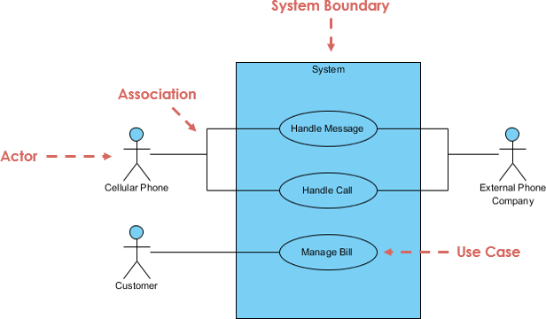

**Actor**

* Someone interacts with use case (system function).
* Named by noun.
* Actor plays a role in the business
* Similar to the concept of user, but a user can play different roles
* For example:
  + A prof. can be instructor and also researcher
  + plays 2 roles with two systems
* Actor triggers use case(s).
* Actor has a responsibility toward the system (inputs), and Actor has expectations from the system (outputs).

Use Case Diagram Notation - Actor

**Use Case**

* System function (process - automated or manual)
* Named by verb + Noun (or Noun Phrase).
* i.e. Do something
* Each Actor must be linked to a use case, while some use cases may not be linked to actors.

Use Case Diagram Notation - Use Case

**Communication Link**

* The participation of an actor in a use case is shown by connecting an actor to a use case by a solid link.
* Actors may be connected to use cases by associations, indicating that the actor and the use case communicate with one another using messages.

Use Case Diagram Notation - Communication Link

**Boundary of system**

* The system boundary is potentially the entire system as defined in the requirements document.
* For large and complex systems, each module may be the system boundary.
* For example, for an ERP system for an organization, each of the modules such as personnel, payroll, accounting, etc.
* can form a system boundary for use cases specific to each of these business functions.
* The entire system can span all of these modules depicting the overall system boundary

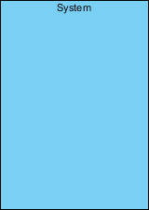

## Structuring Use Case Diagram with Relationships

Use cases share different kinds of relationships. Defining the relationship between two use cases is the decision of the software analysts of the use case diagram. A relationship between two use cases is basically modeling the dependency between the two use cases. The reuse of an existing use case by using different types of relationships reduces the overall effort required in developing a system. Use case relationships are listed as the following:

**Extends**

* Indicates that an **"Invalid Password"** use case may include (subject to specified in the extension) the behavior specified by base use case **"Login Account"**.
* Depict with a directed arrow having a dotted line. The tip of arrowhead points to the base use case and the child use case is connected at the base of the arrow.
* The stereotype "<<extends>>" identifies as an extend relationship

Use Case Diagram Notation - Extend

**Include**

* When a use case is depicted as using the functionality of another use case, the relationship between the use cases is named as include or uses relationship.
* A use case includes the functionality described in another use case as a part of its business process flow.
* A uses relationship from base use case to child use case indicates that an instance of the base use case will include the behavior as specified in the child use case.
* An include relationship is depicted with a directed arrow having a dotted line. The tip of arrowhead points to the child use case and the parent use case connected at the base of the arrow.
* The stereotype "<<include>>" identifies the relationship as an include relationship.

Use Case Diagram Notation - Include

**Generalization**

* A generalization relationship is a parent-child relationship between use cases.
* The child use case is an enhancement of the parent use case.
* Generalization is shown as a directed arrow with a triangle arrowhead.
* The child use case is connected at the base of the arrow. The tip of the arrow is connected to the parent use case.

Use Case Diagram Notation - Generalization

1. **Project for software engineering**

***Problem***

For the MHC-PMS, propose a set of use cases that illustrates the interactions between doctor, who sees patients and prescribes medicine and treatments, and the MHC-PMS

**Solution for the given Problem**

1. ***Problem Description***

As the question describes we are asked to design a use case for the interactions between doctor, who sees the patients and prescribes medicine and treatments for those people who have a mental illness and used that system.

So, we have define or describe the communication that occurred in each component of the system we are going to develop.

1. ***Use case Diagram for MHC-PMS***

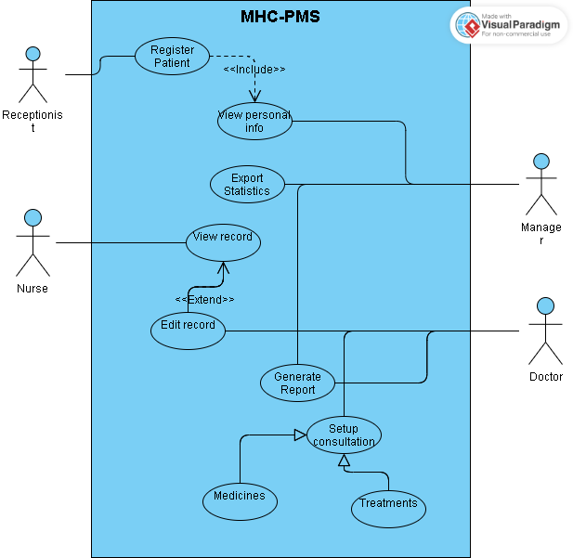

1. ***Explanation***

* The sequence of the steps of the above use case diagram is described as below.

1. Frist, communication initiated by the patient ,who have a mental illness, when the comes to that hospitals
2. Second, the receptionist registers the personal information of the patient who comes to that comes to that health care and stories their information for later.
3. Then, after the receptionist save the personal information of the patient, the manager view the status of the patient from that information and analysis their current status of the patient and finally generate report based on the analysis current status.
4. Fourth, the nurses sees the cause of the current problem of the patient and also compares with the previous or the past healthy record of the patient for which they already treated and edit if the patient problem is expands and shows the new symptoms additional to the previous one.
5. Fifth, the doctor uses the data of information given by the nurse and also the previous or the past healthy record of the patient and comes to evaluate the possible solution for the current patient healthies problem.
6. Finally, after the evaluation, the doctor goings to take an appropriate treatment or action to regulate the patient healthy problem by using different alternatives such as:- giving medicine, advising the better way to prevent or minimize the effect of their sickness, psychotraphy and etc.

References

1. Chatgpt
2. Visual paradigms tutorial